How to run VINS-Mono (Tutorial 1):
roslaunch vins_estimator cuprite.launch → launch file created for cuprite dataset
roslaunch vins_estimator vins_rviz.launch → optional, to display paths
rosbag play ../cuprite/3.bag /imu/data:=/imu0 /monocular_camera/image:=/cam0/image_raw → play cuprite rosbag

Open a terminal
cd Desktop
cd catkin_ws
source ~/Desktop/catkin_ws/devel/setup.bash
roslaunch vins_estimator euroc.launch

Open new terminal
cd ~/Desktop/catkin_ws
source ~/Desktop/catkin_ws/devel/setup.bash
roslaunch vins_estimator vins_rviz.launch
Open new terminal
cd ~/Desktop/catkin_ws
rosbag play ../datasets/MH_01_easy.bag

Notes:
feature tracker, pose_graph → takes image /cam0/image_raw
Type: /cam0/image: sensor_msgs/Image

vins_estimator → takes topic /imu0
Type: /imu0: sensor_msgs/Imu

To run on a different dataset, need to change the outputs of the bag file, or need to change the inputs of the software. For consistency, will rename the outputs of the bag file to match with the VINS-Mono name conventions.

The Cuprite dataset calls the imu topic /imu/data and camera topic /monocular_camera/image

Changing topic names in ROS:
rosbag play file.bag /foo:=/bar

***To run Cuprite dataset with VINS-Mono naming convention:
rosbag play ../cuprite/1.bag /imu/data:=/imu0 /monocular_camera/image:=/cam0/image_raw
***With ground truth:
rosbag play ../cuprite/1.bag /imu/data:=/imu0 /monocular_camera/image:=/cam0/image_raw
Or I can change the config.yaml file in the config folder, by changing the values imu_topic and image_topic.

→ Error: Indexing out of bounds, Neil suggested image size too big → go in Euroc config file and chagne image dimension parameters to:
***Cuprite dataset image height x width:
360 x 640

fx: 465.404692488
fy: 465.155031706
cx: 317.931067441
cy: 173.062115246
k1: -0.0558131259362
k2: 0.0808099678951
p1: -0.001103717824
p2: -0.000170164055868

How to run VINS-Mono (Tutorial 2):
- In VINS-Mono/vins_estimator/launch, a new launchfile called cuprite.launch was created
- In VINS-Mono/config, a new folder named cuprite and in it a cuprite_config.yaml file were created
-
IMU onboard: Xsens MTI-20

Sensor frame origin: X-forward, Y-left, Z-up

“Definition of the frame is in the above figure when operating in mapping/localization without
camera. When using the Feature Tracker, the frame is centered at the front lens of the camera.
Offsets from the above figure are x = +0.0365, y = +0.825, and z = -0.0785.”

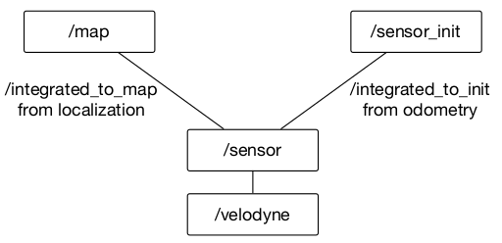

Put odom_to_gt_node in cuprite.launch file
Put static transform publisher in cuprite.launch file → should publish world frame

or do it manually by calling:
static_transform_publisher 0 0 0 0 0 0 1 world sensor_init

So the odometry is a sequence of points, and not a path (a sequence of poses). Don’t need to add odometry, just need to convert into a path.

